**Table of contents**

**Embedded graphics** **1**

How to add a graphic to a Refresher or Guided Practice 1

Refreshers 2

Guided Practices 2

**Defining Links in the authoring tools** **2**

Refresher and GPs only 2

**Link naming conventions and titles** **3**

**Pop-up and image sizing** **4**

**Type conventions and sizes for diagrams (see samples below)** **5**

**Other notes** **6**

**Type conventions and sizes for documents with callouts** **7**

**Uploading files in CAMPER** **9**

When your file won’t open properly 10

**Creating Graphics for JCS100 Citations** 10

# 

# Embedded graphics

“Embedded” graphics are graphics that are pasted directly into the Refresher or Guided Practice “right” columns.

## How to add a graphic to a Refresher or Guided Practice

Open the Refresher or Guided Practice file using Firefox. Other browsers do not work.

Use the PC Snipping tool or comparable tool and copy the graphic. Size it to the appropriate size using a tool like paint.net, and then paste the graphic into the authoring template window.

NOTE! These can increase the size of the file significantly. If you have a lot of graphics to add to a file, do not embed them directly. Instead, upload them to S3 using the CAMPER Ancillary files manager, and then use the “Insert image” capability to add a link to them. See “Defining Links” below.

## Refreshers

Refreshers have a whiteboard on the right. The constraint for the graphic is that it should fit nicely in the white board at the site’s optimized size.

**Max width: 375 pixels**

**Ideal width: 350 pixels**

## Guided Practices

Try its do not have a whiteboard on the right.

You can make a fake whiteboard--put the image in a white rectangle that is **385 pixels** wide, and has a 1 pixel wide gray border 192 192 192. Paste the image into the right pane.

Note: an image like this will overlap the center line. But it will align with the left side of the MC interaction boxes.

If you don’t want your image to overlap the center line, make it **350 pixels** wide, place it in the right pane of the Try it and use html in the source view to align it on the right.

<p style="text-align:right;">

Better yet, place it in the left pane.

# 

# 

# Defining Links in the authoring tools

## Refresher and GPs only

Links defined in CAMPER using the authoring template hyperlink tool can be defined in two ways. BOTH ways will work as relative URLS and pull the files from the bucket that the user is viewing. Prod will pull files from the prod bucket, Dev from the dev bucket, etc.

Old way:

1. Load the file from the S3 dev bucket and copy the first part of the URL. It will look like this:

<https://s3-us-west-2.amazonaws.com/snhu.juice.files/QS1/Rounding>

2. Paste this into the hyperlink editor tool. The protocol will automatically set to https://

This method is RECOMMENDED for embedded images so that you can see and size the images in the authoring tool.

New way:

1. Use this syntax:

S3_BUCKET_/[S3 Destination name]

Where [S3 Destinationo name] is the filename showing in the ancillary files table in CAMPER.

2. Set the Protocol to “other”

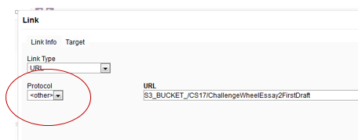

The main benefit of the new syntax is that you do not have to have access to S3 to make these links.

You can use this method for embedded images, but you will not be able to see or size the image in the authoring tool. The full path URL is recommended for embedded images.

# Link naming conventions and titles

Ask yourself: The title of the Picture it within the document should match the title of the “Ask yourself” box. It should include “Ask yourself”

Other Picture its in Did you knows: The title of the Picture it should match the title of the “Did you know” box, except it should not include “Did you know”. Ideally it would also match the link title in the site. Rounding is an exception to this.

Other Picture its NOT in Did you knows: The title of the Picture it should match the link title in the site, except that we do NOT include Picture it in the titles of the files

File names in CAMPER. Try to match the link titles as much possible. Shortened versions are OK if necessary.

# Pop-up and image sizing

If the image is a pdf, it is scaled based on the defined width of the popup window!

Pop-up width:

1. 8.5” wide Picture its: Use 826
2. 10.295” wide Picture its: Use 1000
3. Rounding Picture its: Use 900

Pop-up height:

1. Multi-page templates should be **695** so that the buttons are visible when the resolution is set to be large. A good internal image size that will fit is **565.** Units had to be 560 to avoid scrollbars for some reason.
   1. Known issue: the buttons will not be fully visible when opened in Safari. DO NOT adjust the height of the pop-up to compensate, as this will cause problems for lower resolution displays.
2. Otherwise, 750 is a good starter height. Can be made longer, BUT cannot exceed **800 pixels** for 1600 x 900 monitors
3. If a document is TOO LONG to fit in 800, **use 750 pixels**.
4. If a document is too long to fit in 750 pixels but CAN fit in 800, t**hen use 800,** but adjust the **top offset to 0.**

If the image is a .png, then it is not scaled. It should be made to be 800 wide so that it is centered in it’s window.

# Type conventions and sizes for diagrams (see samples below)

1. Page title: **Lato 20 pt bold purple**
2. Section separators: gray ¾ pt line with width = page width - 0.5 inches. Center this on the page.
3. Section headings: Position underneath gray line with about a 10 px separation. . **Lato 16 pt bold purple**
4. A section heading may include an explanation:

**Plural nouns**: More than one of a person, place, or thing.

If so, use a colon after the heading and make the explanation be plain text.

1. Section labels: Lato 12 pt plain text purple
2. Instructions following Section labels: Lato 12 pt plain text black, with green or red for emphasis.
3. Section labels and instructions may be left or right aligned depending on how long they are. They may be stacked or one line. See samples in 33.4 and 33.7 for different approaches and try to use one or the other.
4. Examples: Lozenge shaped text boxes with gray 1 pt border. Text is Lato 12 pt purple with green for emphasis.
5. Annotations to right of examples: Lato 12 pt plain text black, with green or red for emphasis.
6. Caution notes: Arial 10 pt plain text black, with green or red for emphasis.
7. Large correct / incorrect notes: **Lato 10 pt bold green** or **Lato 10 pt bold red** as appropriate.
8. Double line boxes are .4 tall Single line box: look it up. Make the boxes the same as much as possible.

# Other notes

1. Authoring Picture its in PowerPoint works best.
2. On the MAC, you can take a screen grab of just the part you want and save it as a PDF. Not sure if Windows has this same tool. If not, you can make a PowerPoint with just a single slide and export that to PDF.
3. IMPORTANT! Define the size of your slides before you start work or else it will become very annoying. Design / Slide size.

Ensure fit will change your type size. Maximize will not, but it may move your stuff off the left edge if you are changing the width.

**Sample of a 10.295 wide summary:**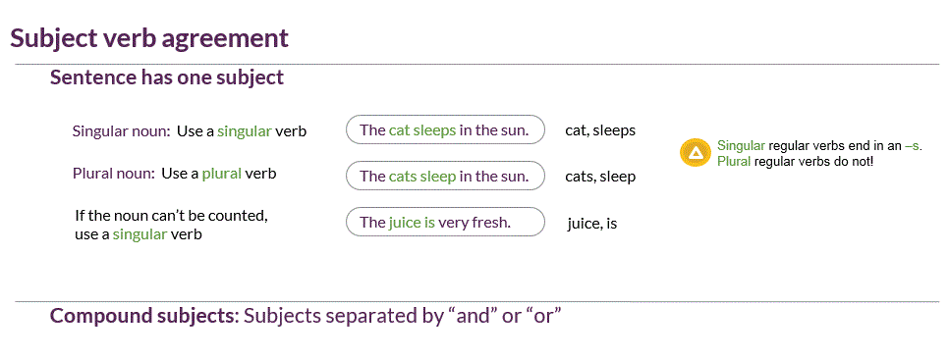

**Sample of a 8.5 side summary:**

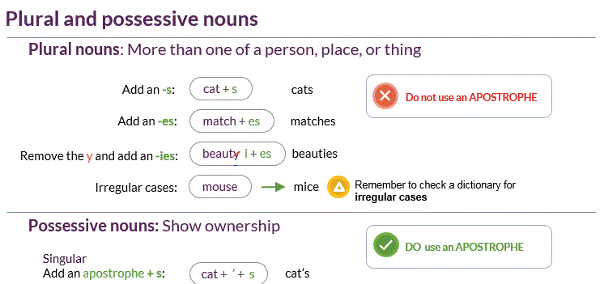

# Type conventions and sizes for documents with callouts

Title = Lato 20 pt bold JUICE purple

Sub headings if needed: Lato 16 point bold JUICE purple, RGB 85-38-86

Body text = Lato 12 pt plain text JUICE gray HEX #59595B, RGB 89-89-91

Callouts :

Make the text margins wide so that there is room for the callouts in the margin.

1 pt thickness Fill = no color, outline = light gray 191 191 191.

Wise words from JUICE: Lato 10 pt JUICE purple

Student talking to him / her self Architect’s daughter 10 pt JUICE purple.

Annotations:

DON’T use a callout--use a regular text box with no outline. . Rotate the box slightly. Architect’ daughter 12 pt blue 0-112-92

Corrections in line:

bold green architect’s daughter 12 pt Point out with a pencil. Green 95-152-66

Text being removed should use a 14 degree red slash if a single character or punctuation. 14 degrees matches the slant of the pencil. Weight = 1.5 Red 192-0-0

If more than one character is being removed, use a horizontal 1.5 red line.

Circle and underlines for corrections: Red 192-0-0

Circles and underline for annotations: blue 0-112-92

Highlighting:

Use when it’s more important to look at the JUICE notes or annotations and see what they are point to than it is to read the whole text.

Do not use when reading the text is the most important and the JUICE notes are secondary.

Misc: Samples:

<http://s3-us-west-2.amazonaws.com/snhu.juice.files/CS16/6/Pictureit_Makesurethepartsworktogether>

<http://s3-us-west-2.amazonaws.com/snhu.juice.files/CS6/5/Pictureit_Annotatingasyourread>

<http://s3-us-west-2.amazonaws.com/snhu.juice.files/CS17/7/Pictureit_Proofreadingandediting>

**File naming conventions for PDF picture its**

1. (If editing/modifying an existing file) download the latest version of source file (powerpoint or word doc version) from the google drive.

2. Open file. Find the file properties and make sure the title is present and MATCHES the title of the Picture it.

3. Make other necessary changes and save.

4. Now make a pdf. You need to use a different method to make the pdf on the Mac than you do on Windows. See notes below for why this is:

MAC USERS:

Use **PRINT** command and in the print menu look for the option to save as a PDF. For PowerPoints, make sure the paper size option is set to a size that matches the dimensions on the source slide. If the paper size is different from the size of the slide, the image will be scaled to fit the paper. In the ‘Paper Size’ drop down menu you can select ‘Manage custom sizes’, and then define the paper size to have the same dimensions as the source slide. This will ensure that the image is not scaled. Edit the title field in the save menu to have the same name as the picture it -- It should NOT be the same as the file name

Example: Fixing sentence fragments

WINDOWS USERS;

Save the file as a PDF. If a title is present, this title will be transferred to the pdf and used in the site.

---

Notes on title behavior:

0. “Title” and “file name” are two different things…. The “Title” is a property of the file that is defined in the document’s properties view.

1. If a title is present in a PDF’s properties, this title will be displayed in the site.
2. If a title is not present in a PDF’s properties, the site will display the CAMPER file name as the title.
3. If you are saving to PDF on the MAC, the PDF title will be the file name of the source document you are saving from to matter what. The file properties title is NOT transferred to the PDF. You must print to PDF to define the PDF file properties title
4. If you are saving to PDF in Windows, the PDF title will inherit the file properties title of your document. If it’s blank, the PDF title will be blank. If it’s present, the PDF will use whatever you have.

# 

# Uploading files in CAMPER

If you upload an .html file, png, or pdf, S3 will recognize the file type and set it appropriately. If you upload Word or any other type of file, S3 will not recognize it and set it to a zip format by default.

This will cause the file to not open properly.

Note that some files are expected to download before they open in some browsers--Word is an example of this.

## When your file won’t open properly

If your file opens showing a directory of some sort, you must access S3, find the file, and set the file type in the metadata properties. For Word, choose MSWord.

Once the file type is set, it will copy from dev to qa and prod

# 

# Sites for free images

<https://pixabay.com/>

<https://unsplash.com/>

<https://burst.shopify.com/>

# Creating graphics for JCS100-citations

All of the resource graphics used in JCS100 (with a couple of exceptions that will be noted with the specific file in TRACKING for Picture its, embedded graphics, and ancillary content files) Overviews, Try its, and games are created in Microsoft word and exported as PDFs.

## Edit an existing graphic

Information on the location of existing JCS100 graphics, their source and working copy files, and notes on how the graphic was initially created can be found at:

[TRACKING for Picture its, embedded graphics, and ancillary content files](https://docs.google.com/spreadsheets/d/1fwk0rCfcXrzavE6ODzeMdlHQCzrQQYO_zQi96qV6uu8/edit#gid=0)

All JCS100 graphics are indexed on the EXTERNAL Picture its tab.

## Create a new graphic

Begin by downloading one (or all) of the premade Word templates. They can be found in the Google drive in CORE JUICE Content Dev/Graphics/Ancillary files/JCS100.

Each template has a purple frame for you to design within. There are currently three:

* **JCS100-Webpage template** -- Used for mocking up web pages and other online content. The page setup is preset to 8.5 x 13” and is oriented in landscape layout.
* **JCS100-Print template** -- Used for mocking up books, magazines, and other printed resources. The page setup is preset to 8.5” SQ (8.5 x 8.5”) and is oriented in portrait layout.
* **JCS100-side by side template** -- Used for presenting a printed resource’s Cover and inside page(s) or for comparing two print sources side-by-side. The page setup is preset to The page setup is preset to 8.5 x 13” and is oriented in landscape layout.

Open the template that best matches the resource you’re creating and Save As the file name you wish to use.

The file naming convention is:

MinilessonID.widgetype_short name or game round #_version#_date of version

Example file names:

JCS100.5.Overview_KucharCopyright_v5_113017

JCS100.5.Tryit2_magazinecover_v2_120117

JCS100.5.spotlight_round1_v1_092017  
  
Go to the document’s page setup options. Under “Paper Size” option select manage custom sizes. Set the paper size to match the templates dimensions, then set the Non-Printable area to User Defined and enter 0 in the fields for Top, Bottom. Left, and Right margins. This is required to make the “Source is fictional” disclaimer banner display all of the way to the edge of the page. You can save and name this custom size for future use when working with a blank template with the same dimensions (eg, Full Bleed 8.5x8.5 for Print Template, or Full Bleed Web for Webpage template.

Save your document now to maintain Page Setup.

Next, download JCS100-fictional source banner (Word Doc) from the Google drive (CORE JUICE Content Dev/Graphics/Ancillary files/JCS100)

Copy the banner from this doc into the document you’re editing. Position it to display in the upper left corner. With the banner still selected, go to Layout/Position/More Layout options/Text Wrapping and select In Front of Text.

NOTE: All graphic elements should be set to display In Front of Text. This will allow you to rearrange any given elements without shifting others on the page.

NOTE: You may need to adjust the size of the purple frames to create enough space for the disclaimer banner to fit in the upper-left corner without overlapping with the other graphics

Now you’re ready to begin designing your resource within the purple frame.

Some types of resource graphics, such as book copyright pages and Youtube videos use base assets that can be modified for use in a new resource.

**Book Copyright pages** -- All of these graphics are modified versions of the copyright page graphic used in JCS100.5 Overview. The source document for this graphic is JCS100.5.Overview_KucharBook_FULLeditable_v5_110717.docx found in embedded graphics/JCS100/JCS100.5/Working copy. The layout of this copyright page is taken from a template found at <https://www.thebookdesigner.com/2010/01/copyright-page-samples-you-can-copy-and-paste-into-your-book/>

**YouTube pages** -- Graphics for YouTube page resources are built up from a screen grab of a youtube video player. This source image can be found at CORE JUICE content dev/Graphics/Source images JCS100. Microsoft Word shapes and text boxes are used to cover aspects of this source with information needed for the lesson. Shapes are also used to cover YouTube logos.

**Website Graphics** -- Most web graphics contain a URL bar, which was created by snipping the URL bar from a browser window and modifying it for each use using shapes and text boxes in Word. The original URL bar image can be found at CORE JUICE content dev/Graphics/Source images JCS100

## Create thumbnail version

Some resource graphics require separate thumbnail versions. These look the same as the full-sized versions (include callouts etc.) but but are sized to display in a mini-lesson step and include an orange plus symbol in the upper right corner to denote that the graphic can be expanded. These orange symbols can be found in the editable version of the graphic’s source document. Place the orange symbol in the upper right corner of the graphic (try to match positioning used in JCS100.5 overview) and take a snip of the graphic, leaving enough room for the whole orange symbol. Confirm the snipped file is saved as a .PNG and then resize to 350px width. The thumbnail should now be ready to add to a lesson. Remove the orange symbol before taking the final snip of the editable graphic for use in the source document, or before saving as a PDF.

## Saving graphics

When you’re finished designing, save your file as a PDF. See the section “File naming conventions for PDF picture its” to edit the display title of the file and save as a PDF. The process if different for PC and Mac.

An online PDF compression tool was used to shrink PDF files that we 1mb or over. It is found at: <https://smallpdf.com/compress-pdf>

Because it is a free tool, there is a limit of how many documents can be uploaded in an hour (I believe that it is 3 an hour).